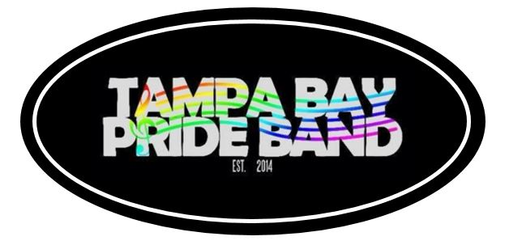
Tampa Bay Pride Band
Sponsorship Form
Date:
Name: ____________________________________________________________________________________________
Contact Person & Title: ____________________________________________________________________________
Street Address (NO PO BOX): ______________________________________________________________________
City ________________________________________ State __________________________ Zip __________________
Phone Number: (_________) ___________________ Email: _________________________________________
Website: _________________________________________________________________________________________

Sponsorship Levels

 |  | Red | $500 - $999 | - Title of Community Sponsor  - 2 Tickets per concert for 1 year  - Reserved Seating
 |  | Orange | $1,000 - $2,499 | - Title of Community Sponsor  - 4 Tickets per concert for 1 year  - Reserved Seating
 |  | Yellow | $2,500 - $4,999 | - Title of Community Sponsor  - Name & Logo on Organization Advertisement/Promotion  - 4 Tickets per concert for 1 year  - Reserved Seating
 |  | Green | $5,000 - $7,499 | - Title of Community Partner  - Name & Logo on Organization Advertisement/Promotion  - 6 Tickets per concert for 1 year  - Reserved Seating
 |  | Indigo | $7,500 - $9,999 | - Title of Community Partner  - Name & Logo on Organization Advertisement/Promotion  - 8 Tickets per concert for 1 year  - Reserved Seating
 |  | Violet | $10,000.00+ | - Title of Community Partner  - Name & Logo on Organization Advertisement/Promotion  - 10 Tickets per concert for 1 year  - Reserved Seating  - T – Shirt Sponsor for Marching Band Events  - Concert Title Sponsorship

Community Sponsors will have their names listed only and hyperlink to their organizations.
Community Partners will have their name and logo listed and the logo hyperlinks to the organization’s website.

